Basic Level Questions
Q1. List all unique cities where customers are located.
Python: 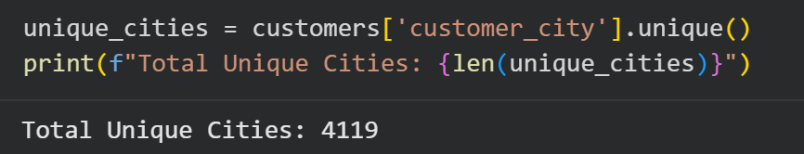

SQL:
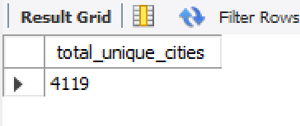

Q2. Count the number of orders placed in 2017.
Python:
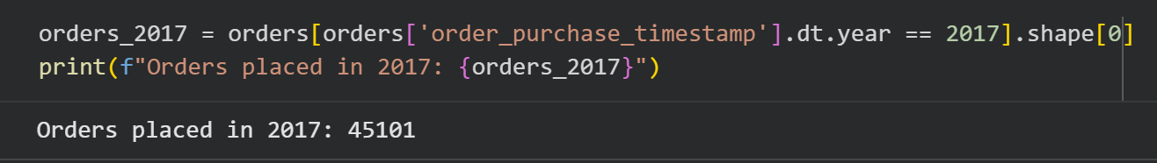

SQL:
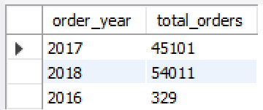

Q3. Find the total sales per category.
Python:
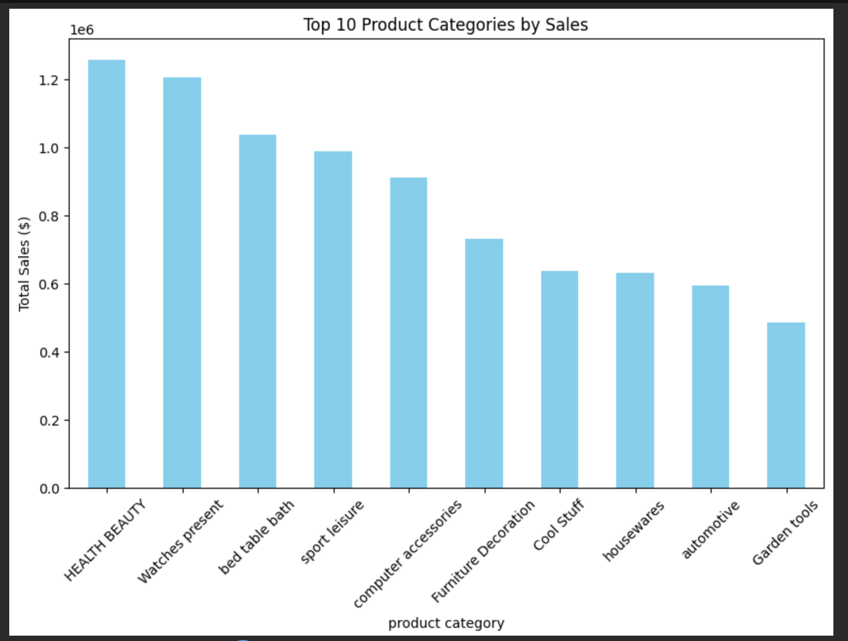

SQL:
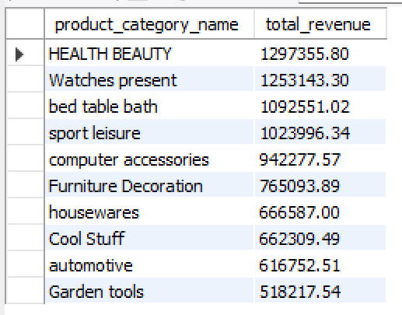
Q4. Calculate the percentage of orders that were paid in more than one installment.
Python:
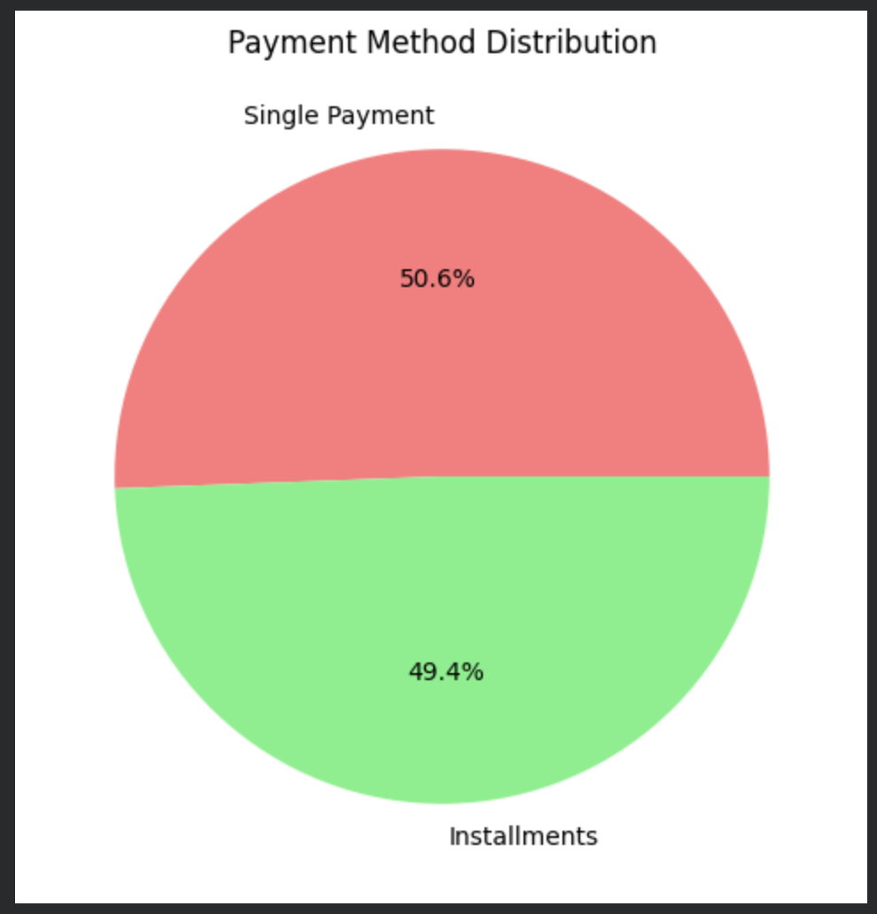

SQL:
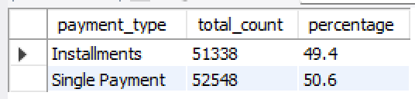

5. Count the number of customers from each state.
Python:
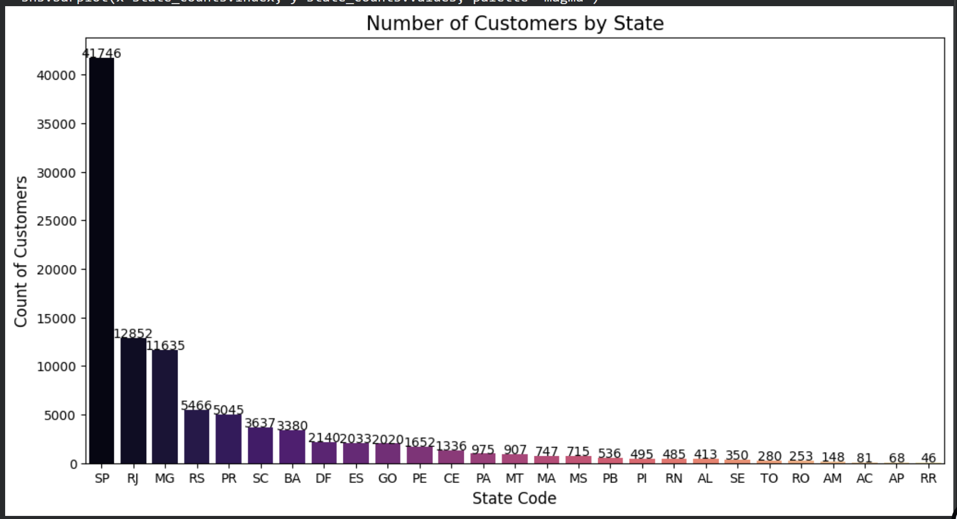

SQL:
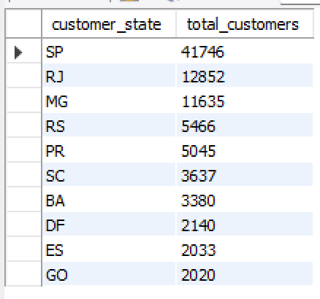
Intermediate Level Questions
Q1. Orders per Month in 2018.
Python:
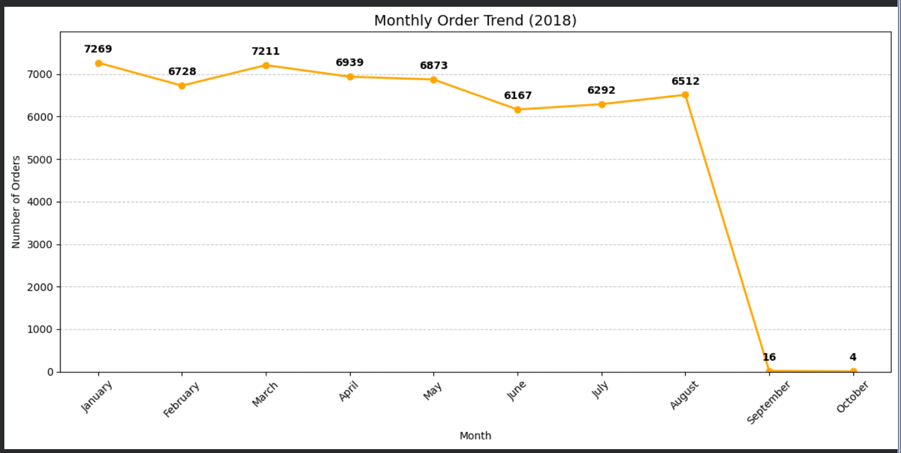

SQL:
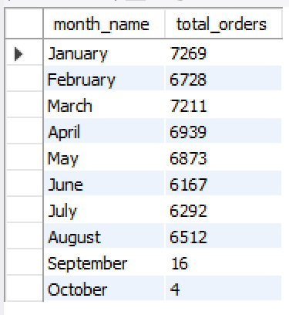
Q2. Average Number of Products per Order (Grouped by City).
Python:
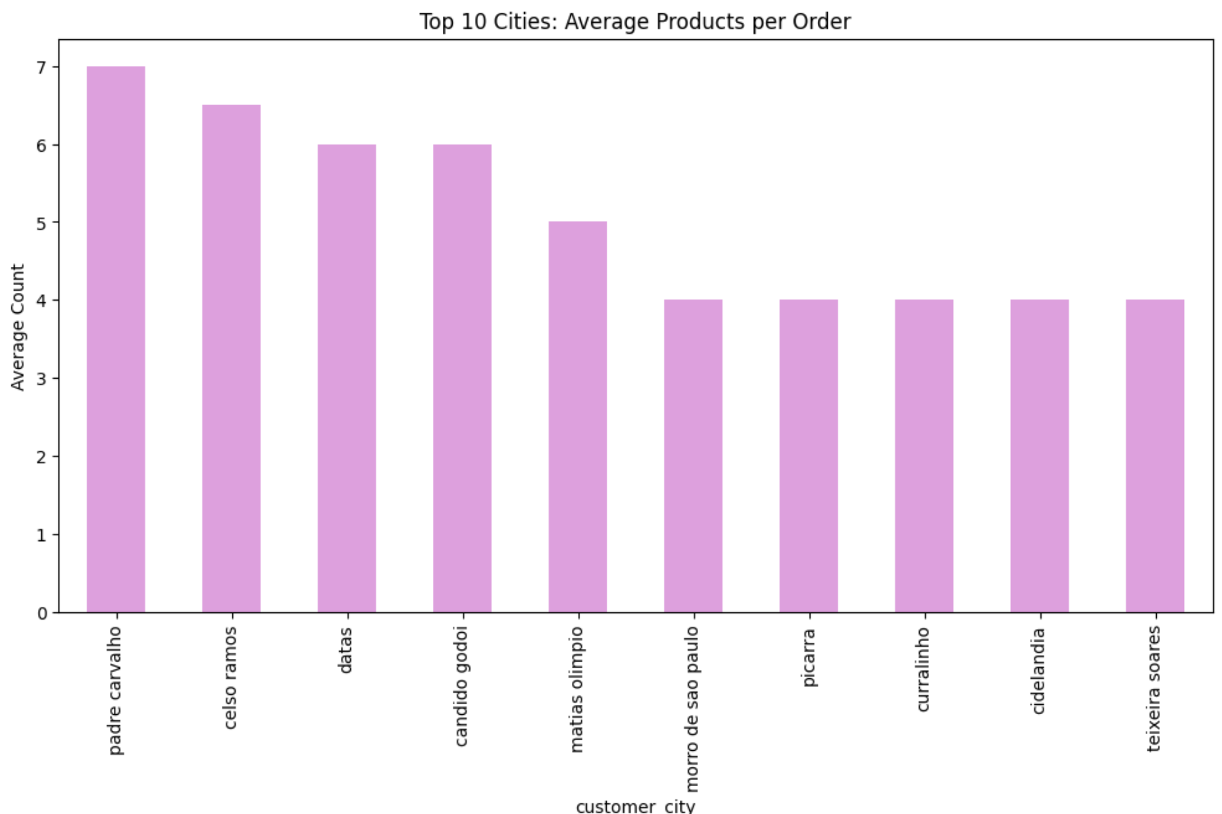

SQL:
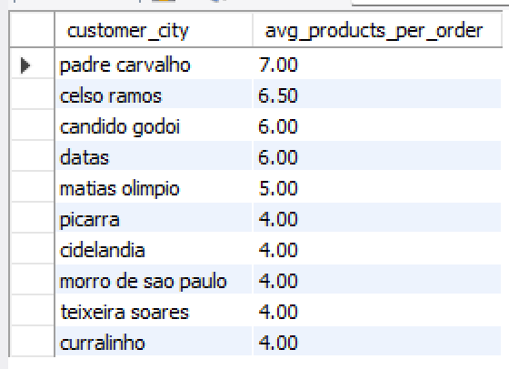
Q3. Percentage of Total Revenue by Product Category.
Python:
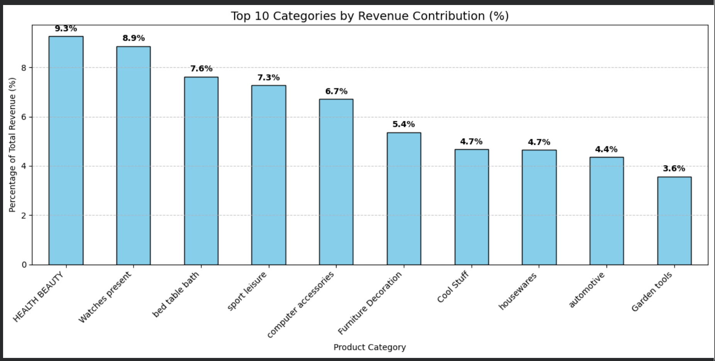

SQL:
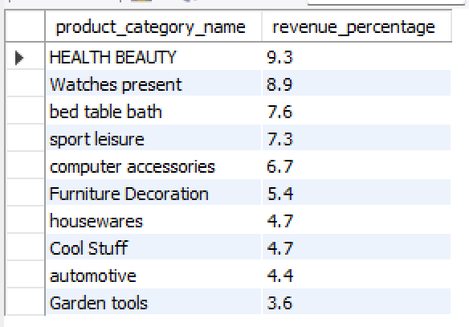

Q4. Correlation Between Product Price and Purchase Count.
Python:
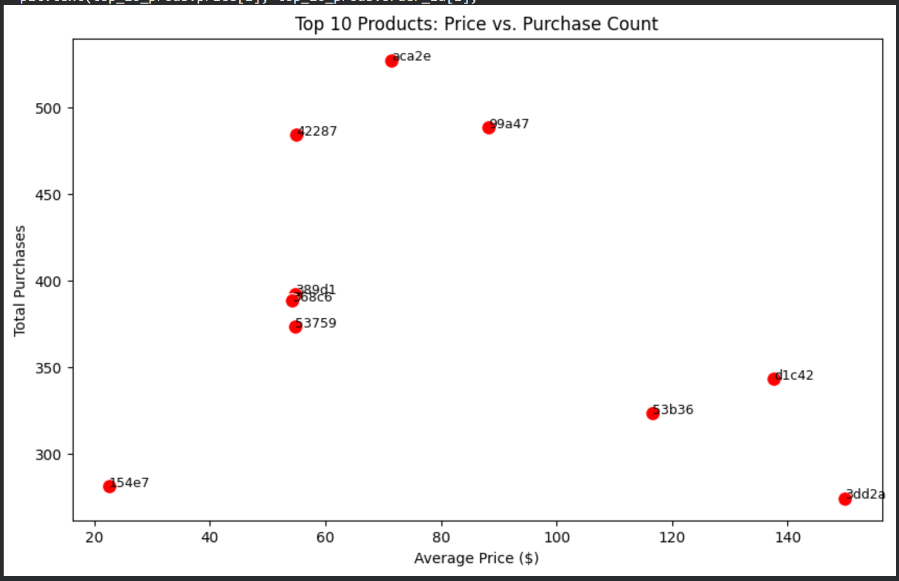

SQL:
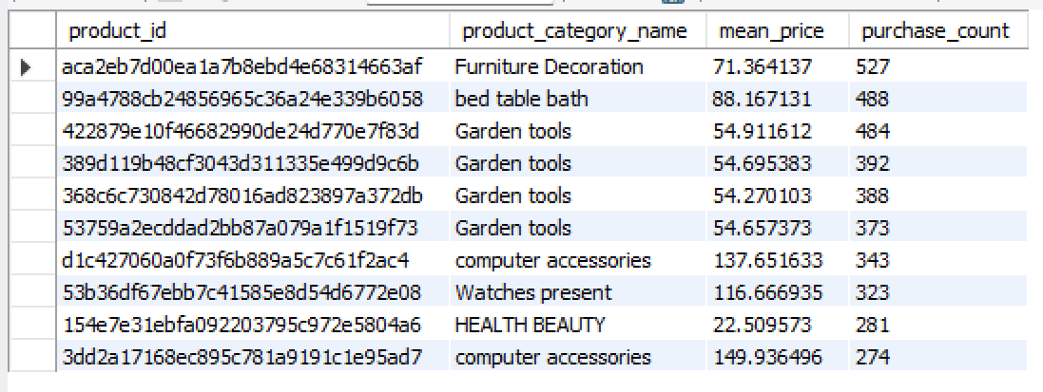
Q5. Total Revenue Generated by Each Seller (Ranked).
Python:
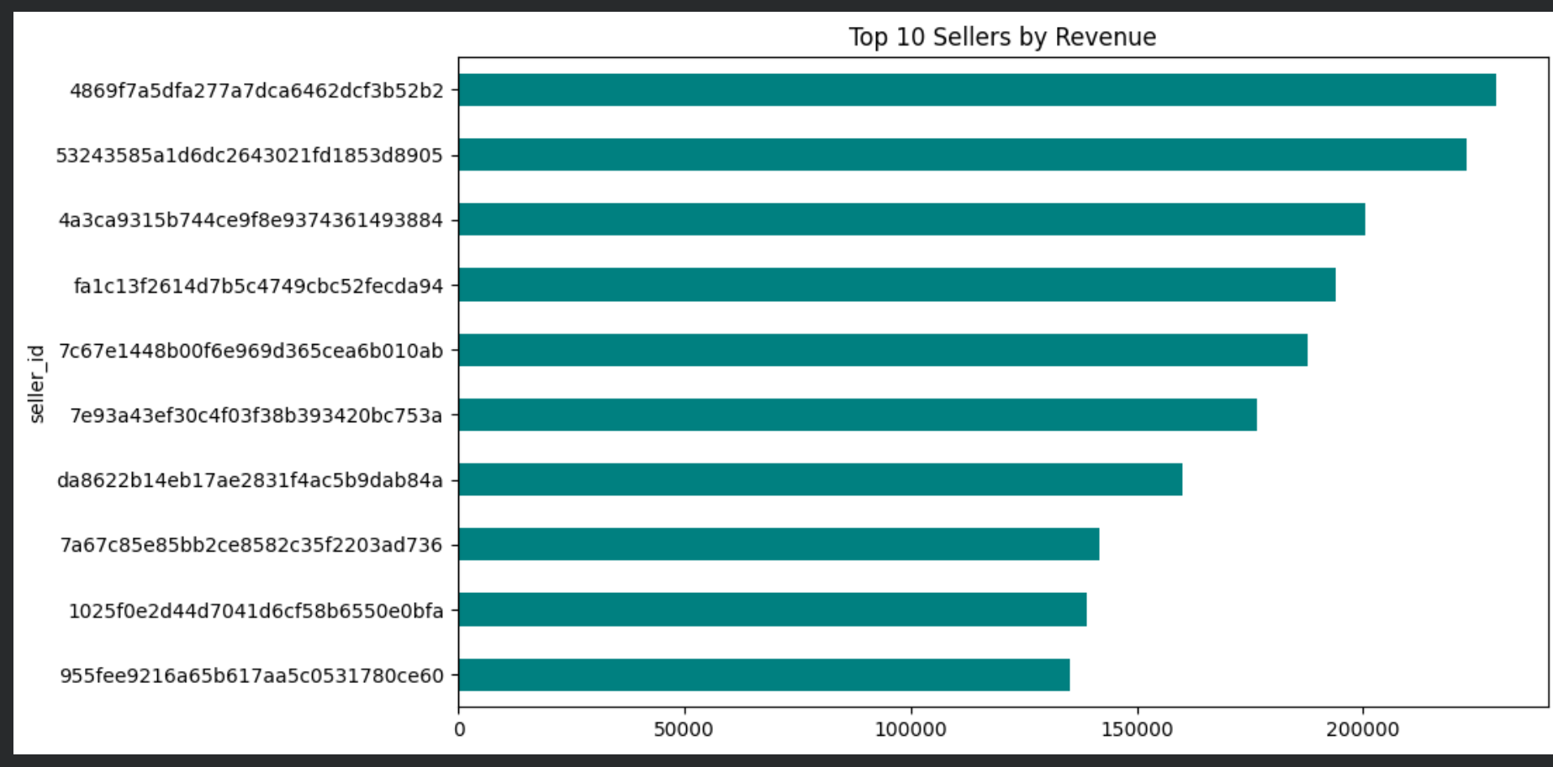

SQL:
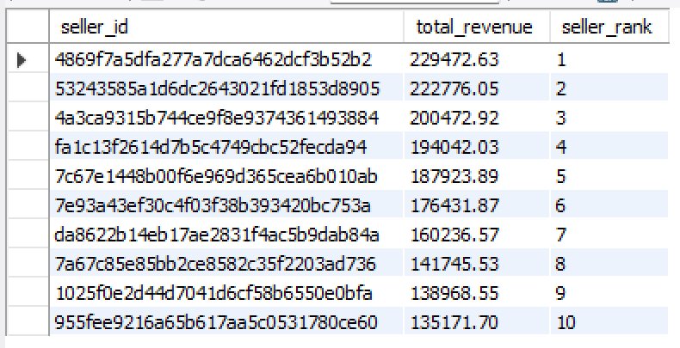

Advanced Level Question
Q1. Moving Average of Order Values.
Python:
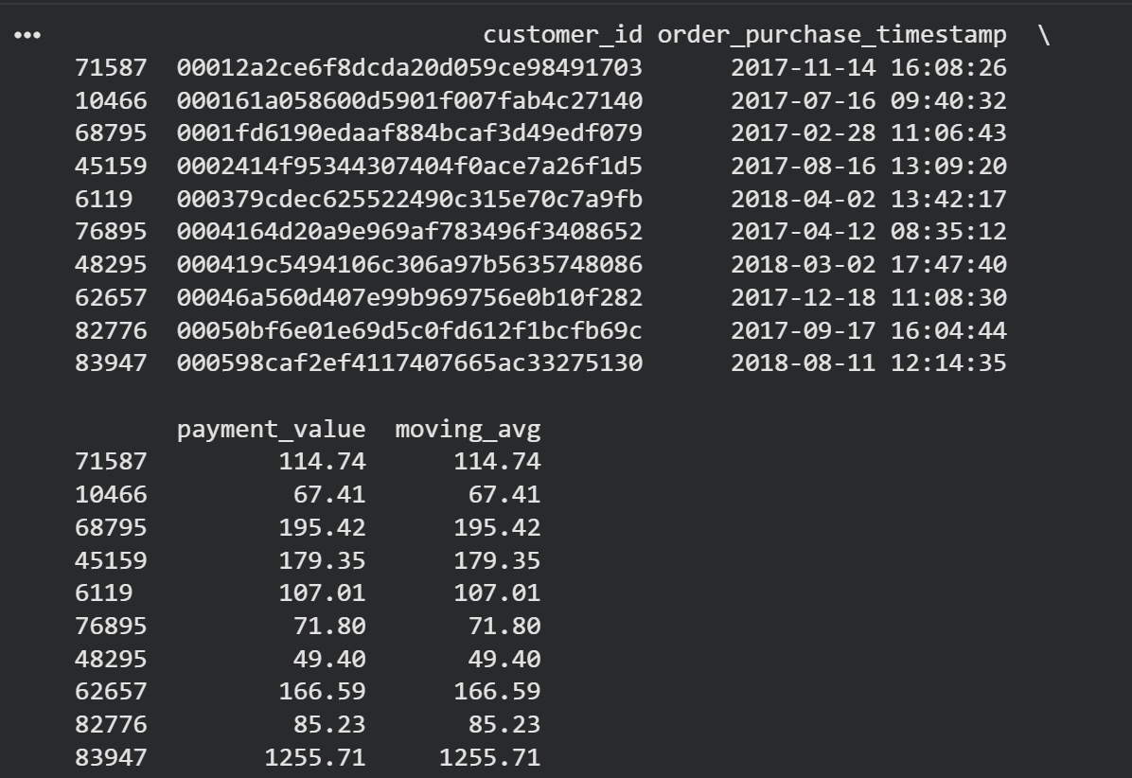

SQL:
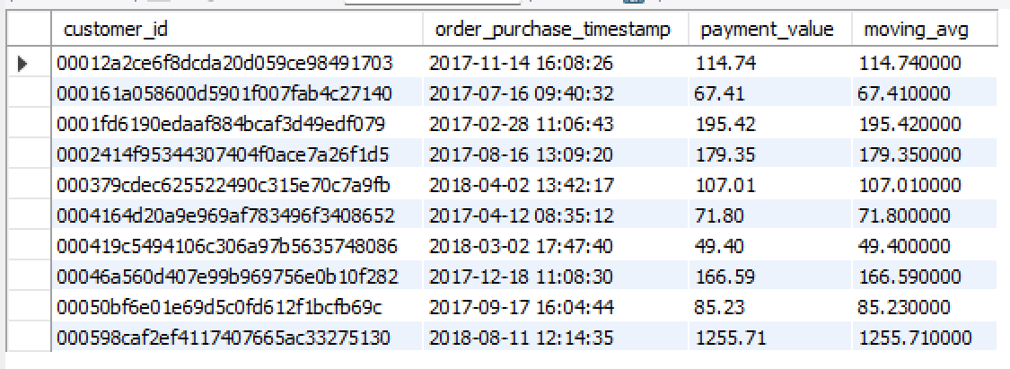
Q2. Cumulative Sales per Month for Each Year.
Python:
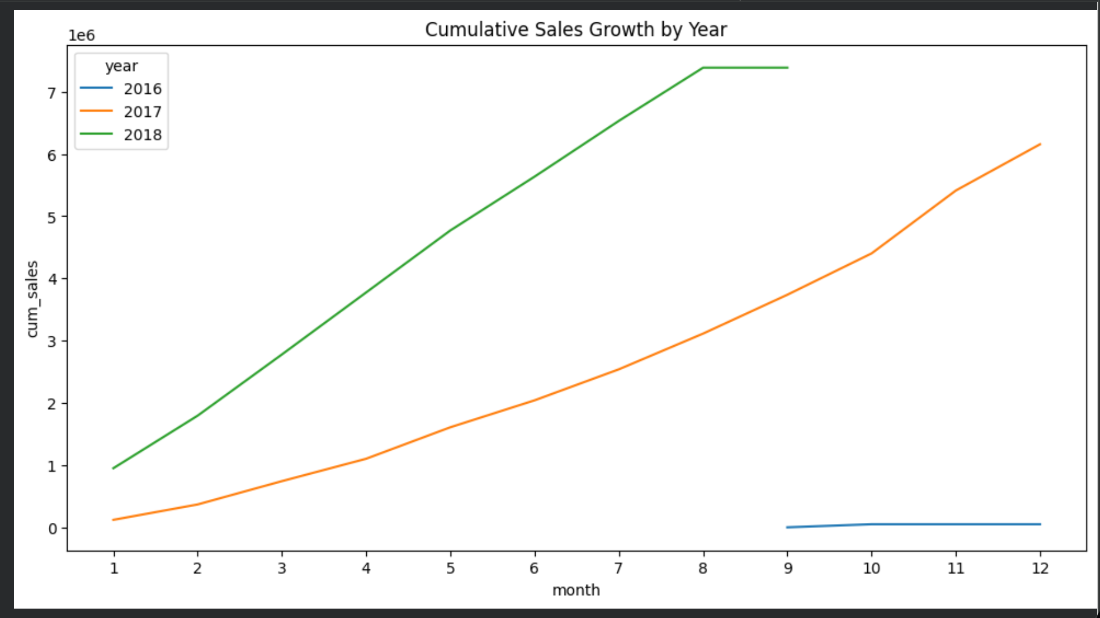

SQL:
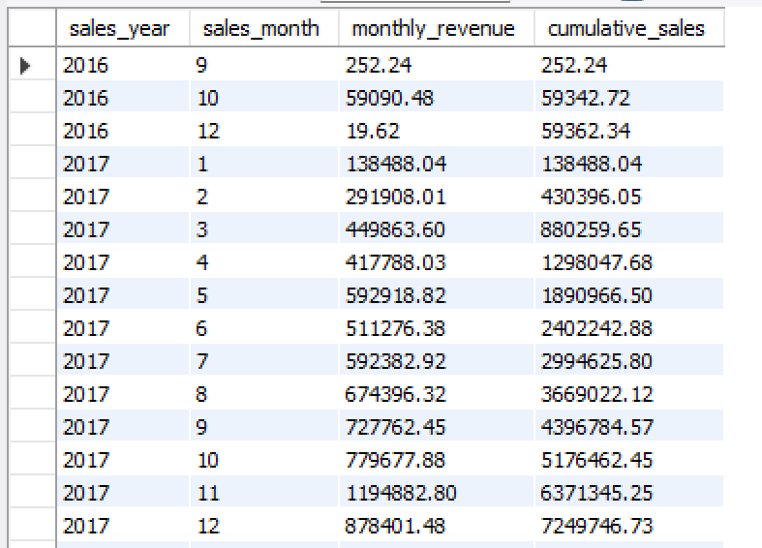
Q3. Year-over-Year (YoY) Growth Rate.
Python:
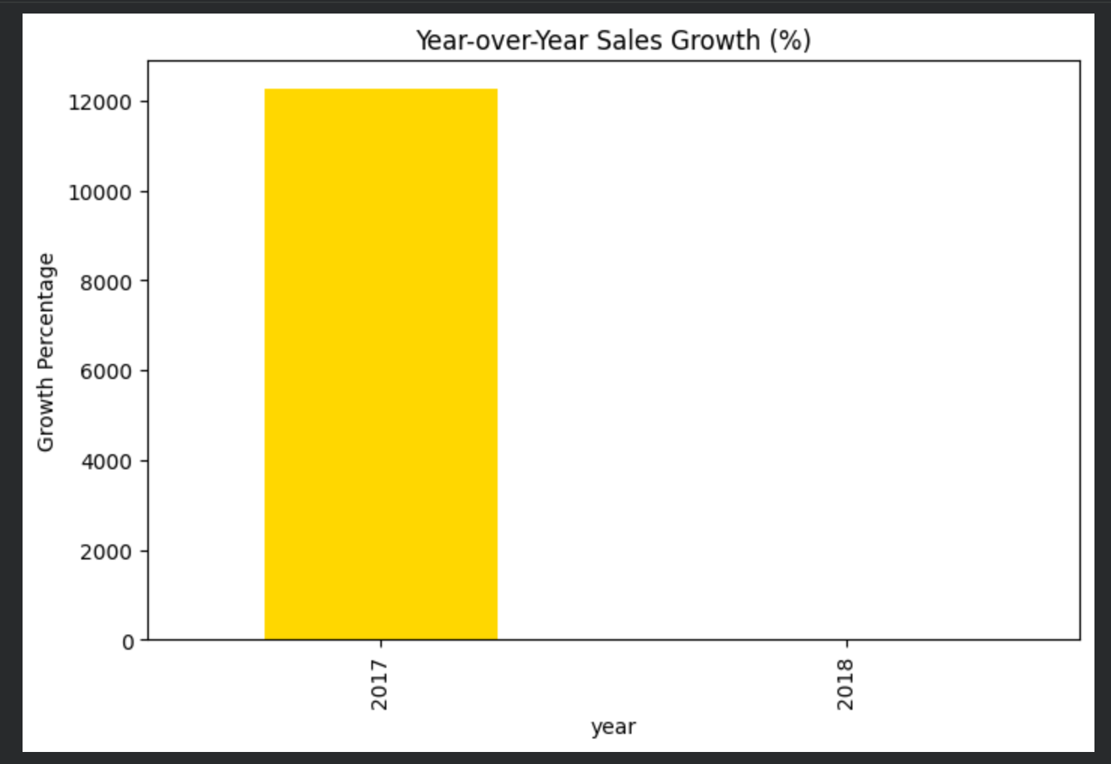
SQL:
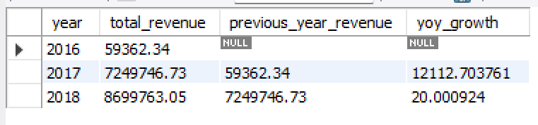

Q4. Retention Rate (Repeat Purchase within 6 Months).
Python:
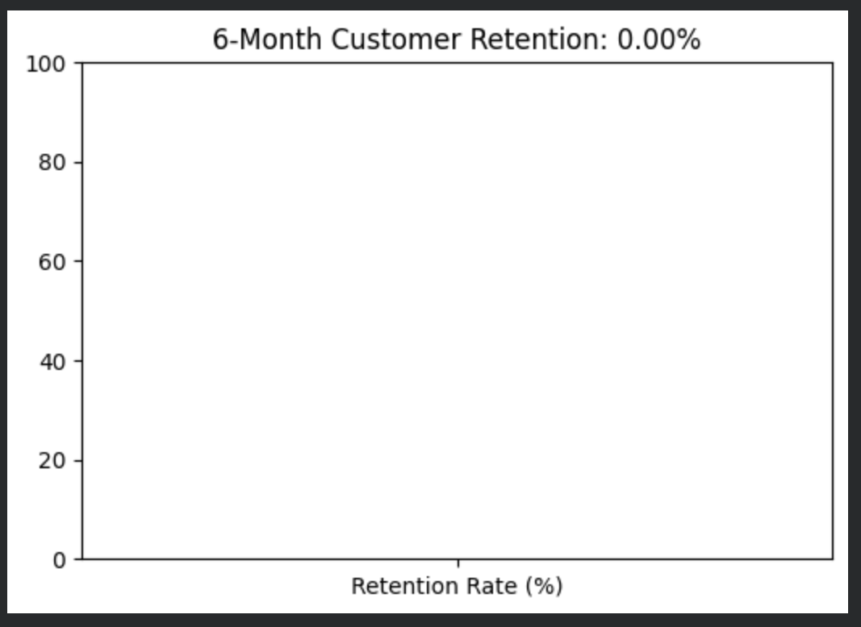

SQL:
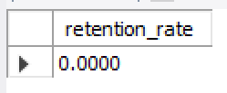

Q5. Top 3 Customers Who Spent the Most Each Year.
Python:
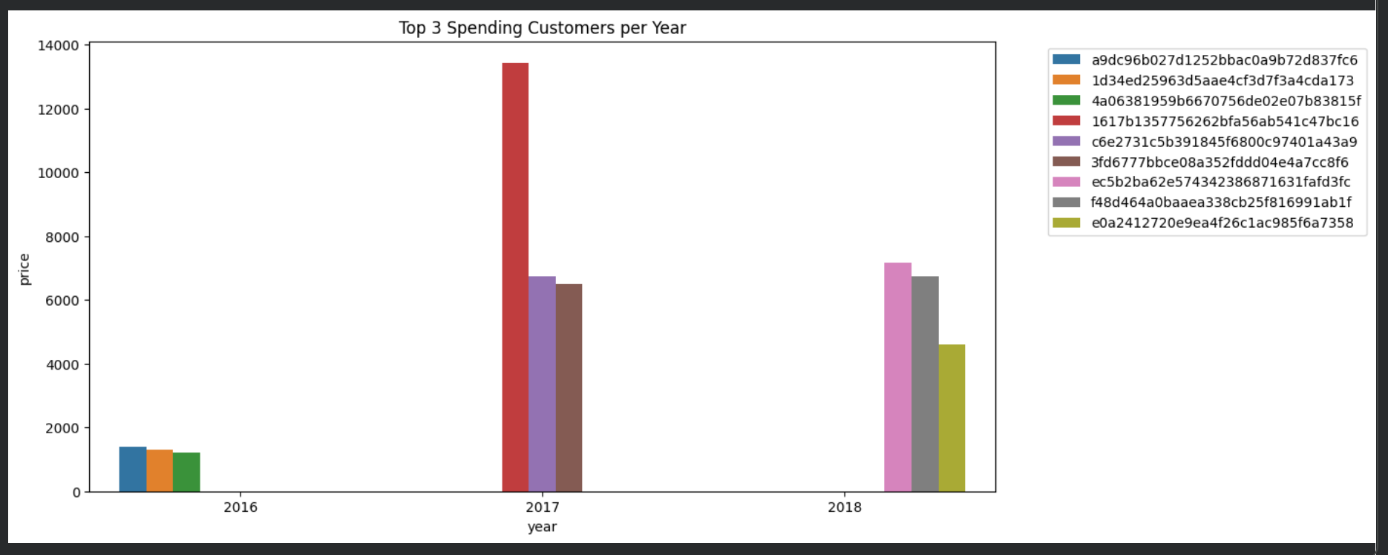

SQL:
